Tuto accounts Rockstar Method:

To start you must create an Outlook account, once the account is created you will create a Rockstar and Epic Games account with the Outlook email address

After creating the 3 accounts you must launch the Epic Game launcher with the account you have just created then you purchase Grand Theft Auto V on Epic game.

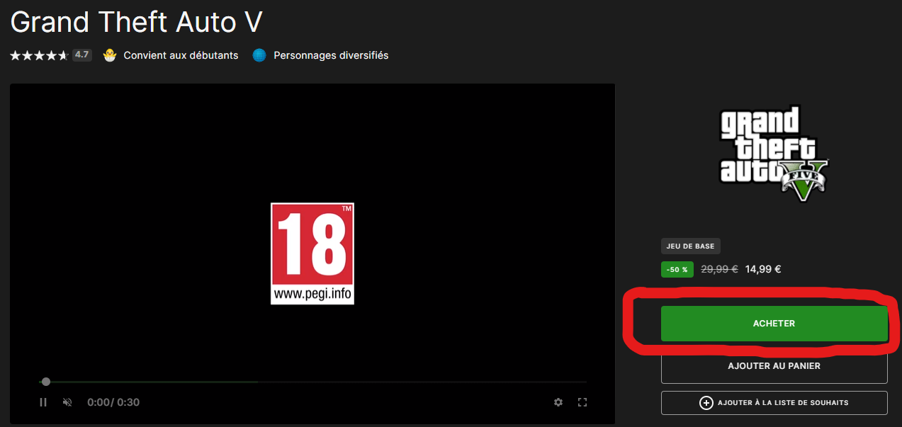
After purchasing it, you must launch it on Epic game. Epic Game will ask you to link your Epic Game account to Rockstar and you will link your new account.

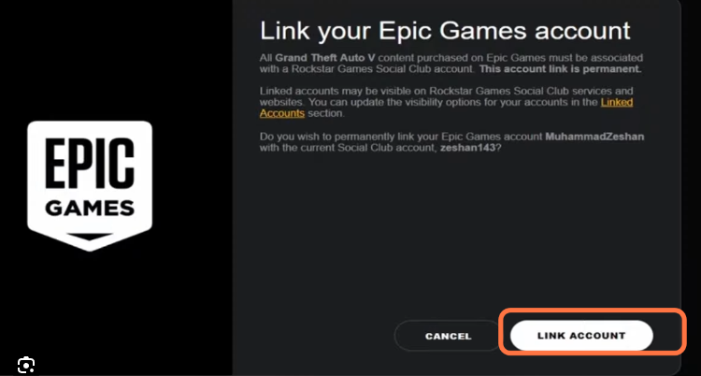
After launching the game you quit it and request a refund on the Epic game website. The refund is done instantly.

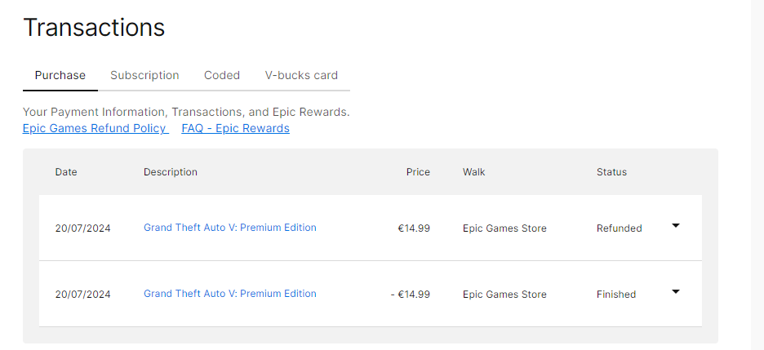
Once refund the account is ready and completely unbanned so to start again you have to redo the manipulation again and again.

